# Vue JS 3 tutorial in Hindi #1 Introduction

<https://www.youtube.com/watch?v=h18hbBNxXac&list=PL8p2I9GklV45e7L_qC_mntM7FhSIV8pqa&index=1>

1. 
2. 
3. 

# Vue JS 3 tutorial in Hindi #2 How to use VueJs with CDN

<https://www.youtube.com/watch?v=2EbptgNaBt8&list=PL8p2I9GklV45e7L_qC_mntM7FhSIV8pqa&index=2>

1. 
2. 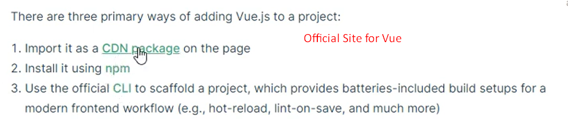

# Vue JS 3 tutorial in Hindi #3 Installation with CLI

1. 
2. Command:
   1. vue create <app-name>
   2. npm start serve

# Vue JS 3 tutorial in Hindi #4 File and Folder Structure

1. Let’s study
   1. package.json
   2. package-lock.json
   3. component = template + script + CSS

# Vue JS 3 tutorial in hindi #5 Code Flow and vue extension

1. 
2. **Install Extension**:
   1. vue
   2. vue format.

# Vue JS 3 tutorial in hindi #5 Code Flow and Vue extension

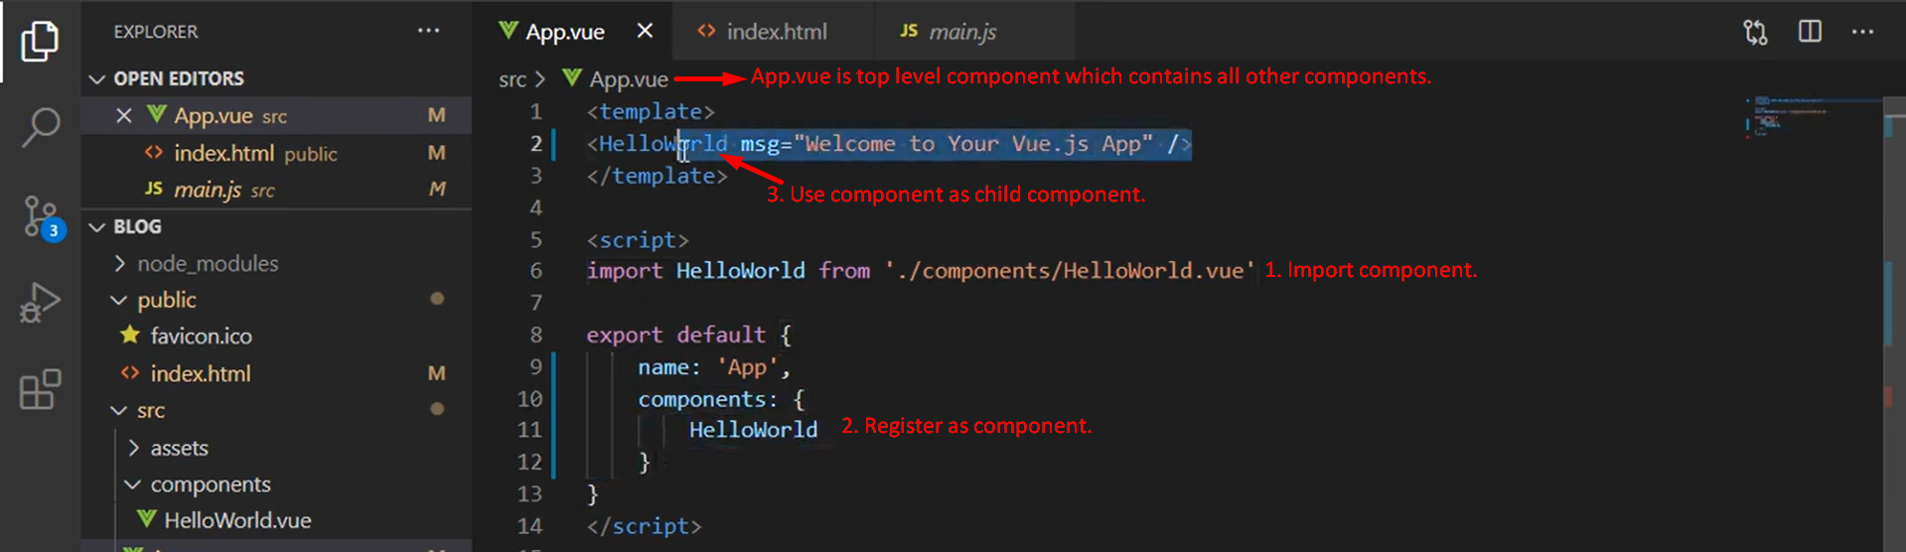

# Vue JS 3 tutorial in Hindi #6 Make First Component

1. 
2. Component: A piece of code.
   1. Analogy: Car consists of many components.
   2. Reusable: Header.
3. <style **scoped**>: To bind style to a component.

# Vue JS 3 tutorial in Hindi #7 Interpolation and Data

1. 
2. Interpolation: Helps us to use following JS constructs in HTML.
   1. variables, functions, operations
3. Example: Write in HTML
   1. {{10+10}}
   2. {{“Jatin”.length}}
4. 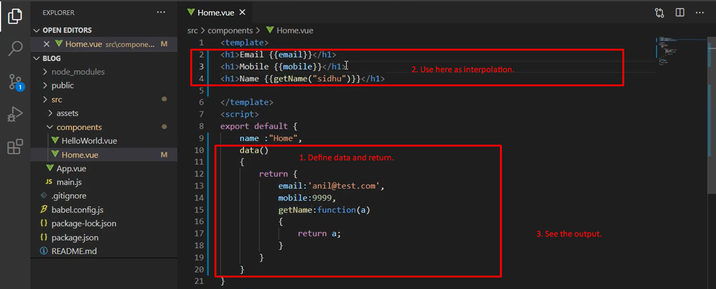 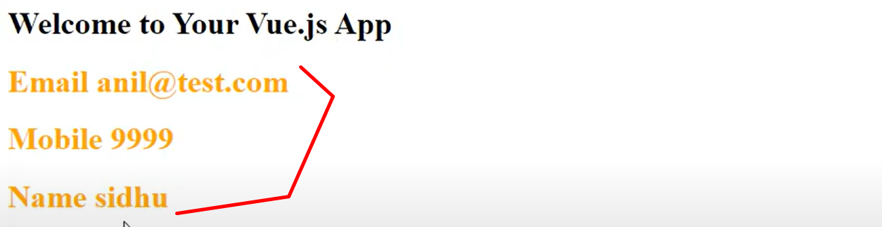
5. 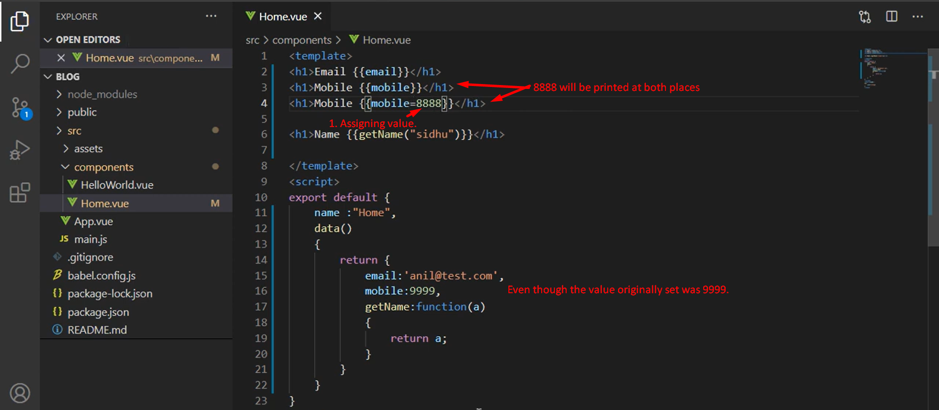 

# Vue JS 3 tutorial in Hindi #8 Methods with Param

1. 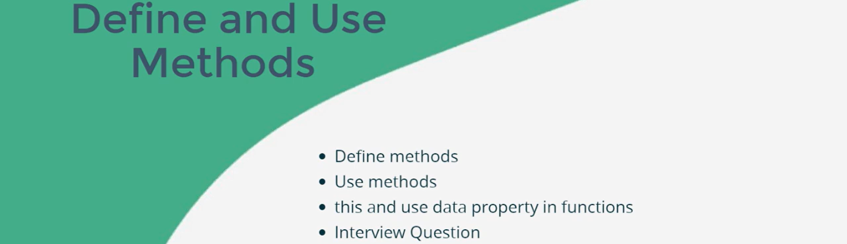
2. 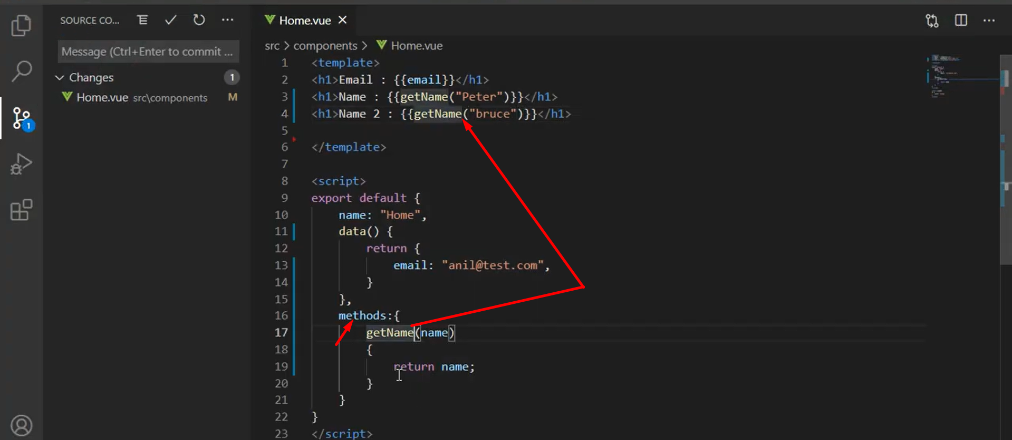
3. 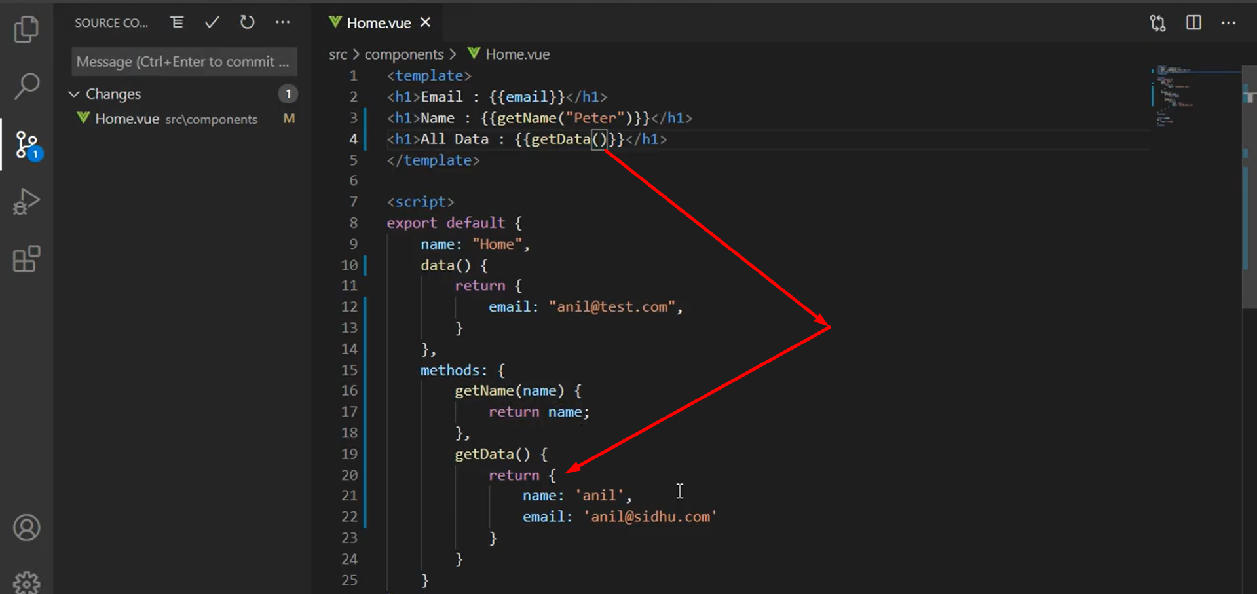  
   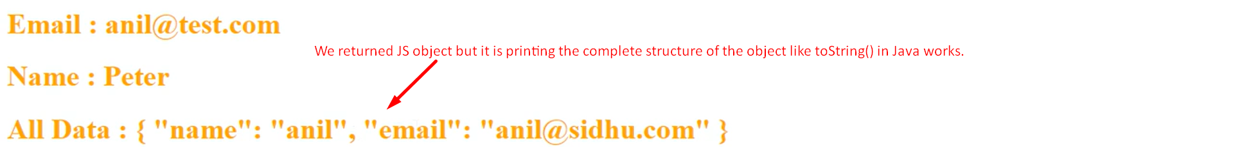
4. 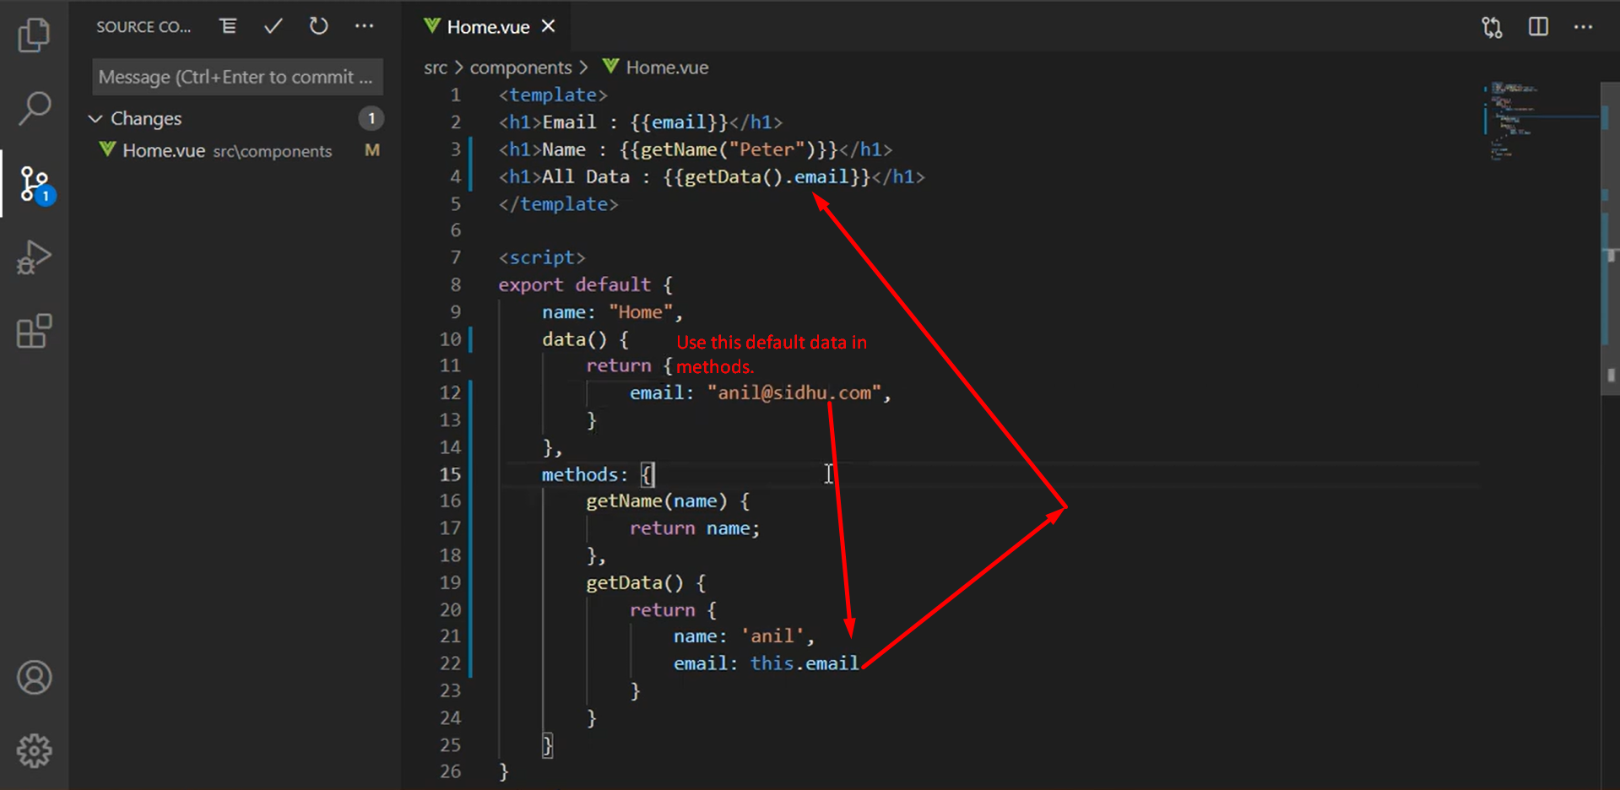

# Vue JS 3 tutorial in Hindi #9 Event with example, click event

1. 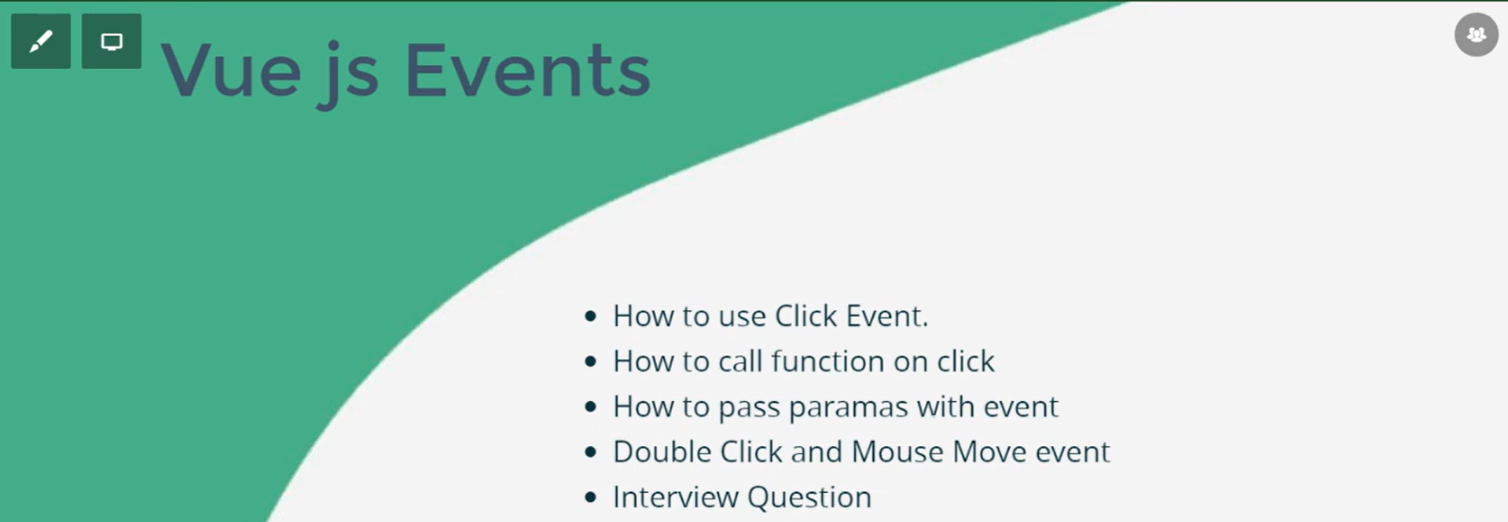
2. 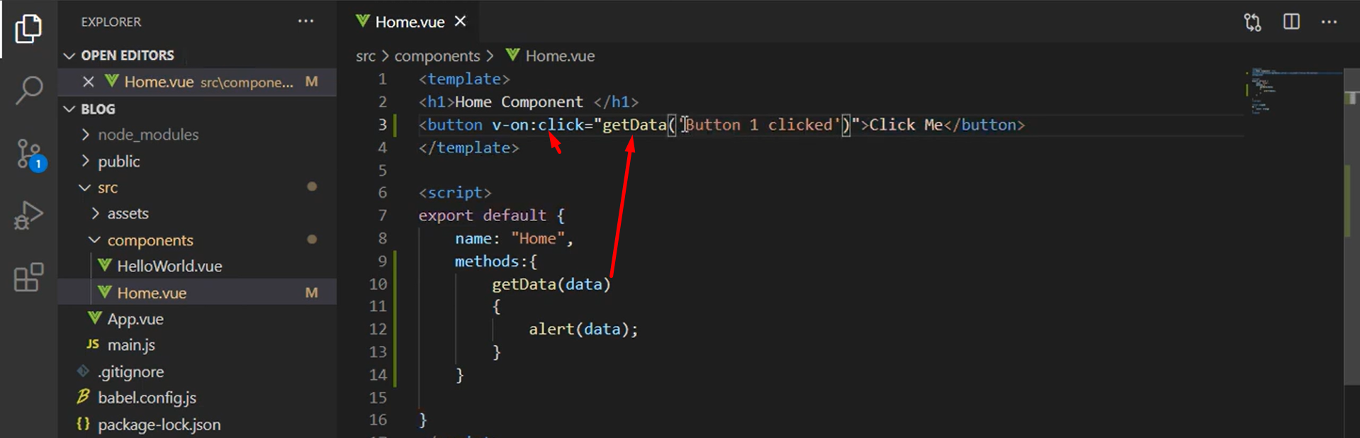
3. 
4. 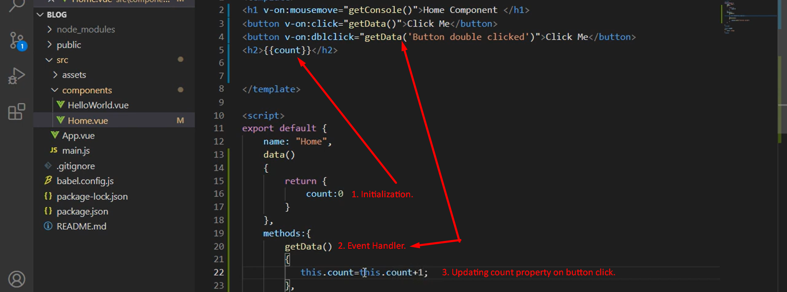

# Vue JS 3 tutorial in Hindi #10 Two way binding

1. 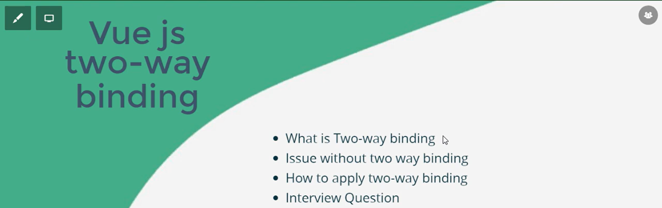
2. **Synchronization**: View <- -> Model.
3. 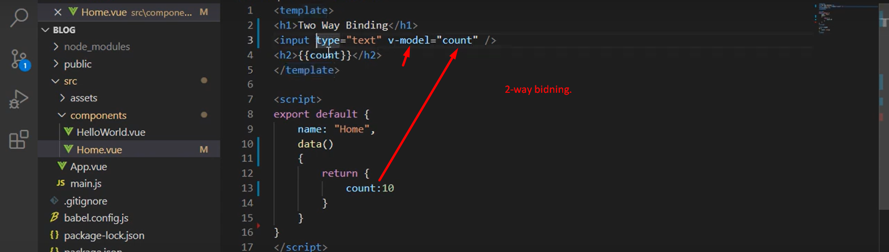

# Vue JS 3 tutorial in Hindi #11 Get input value

1. 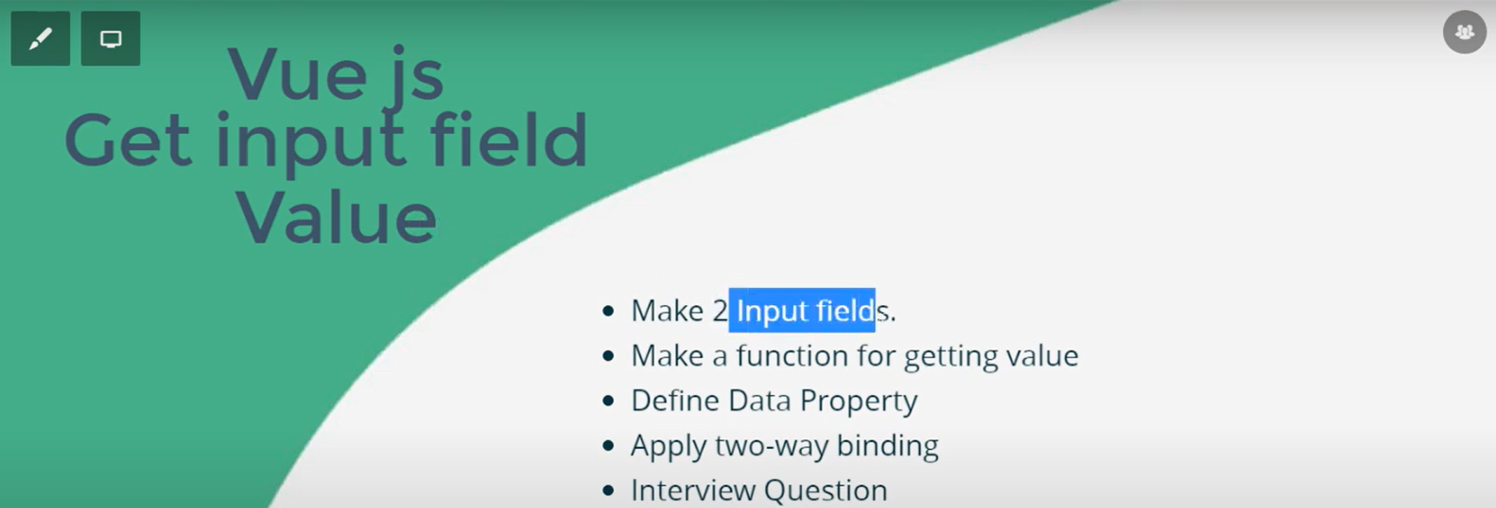
2. 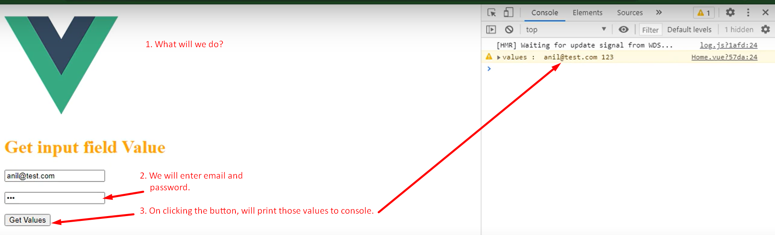
3. 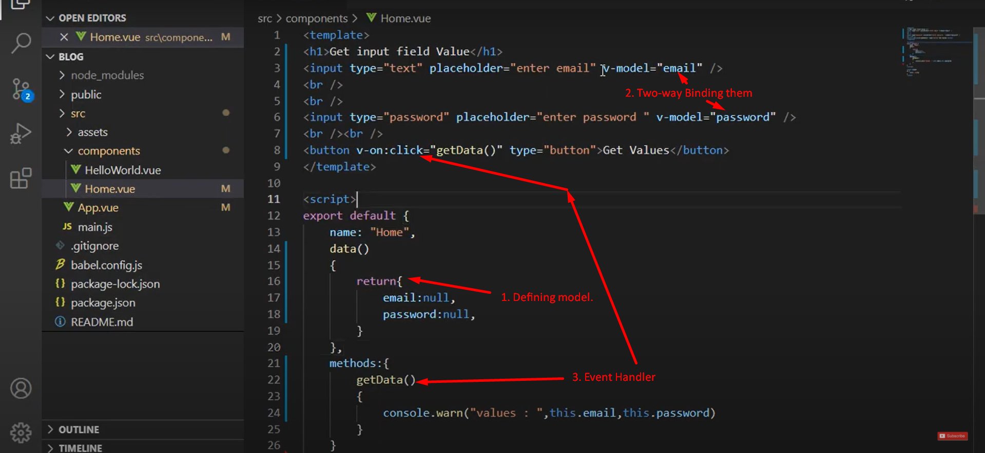

# Vue JS 3 tutorial in Hindi #12 Get Checkbox & Radio Button Value

1. 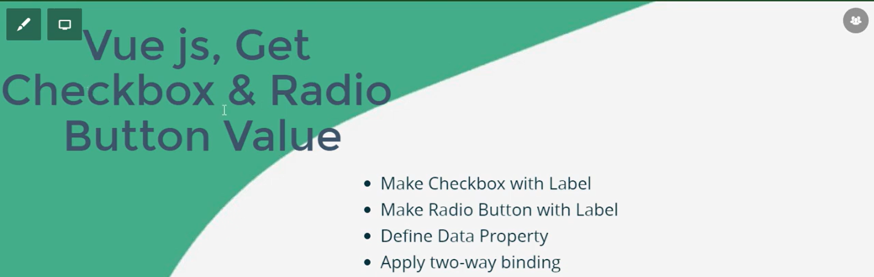
2. 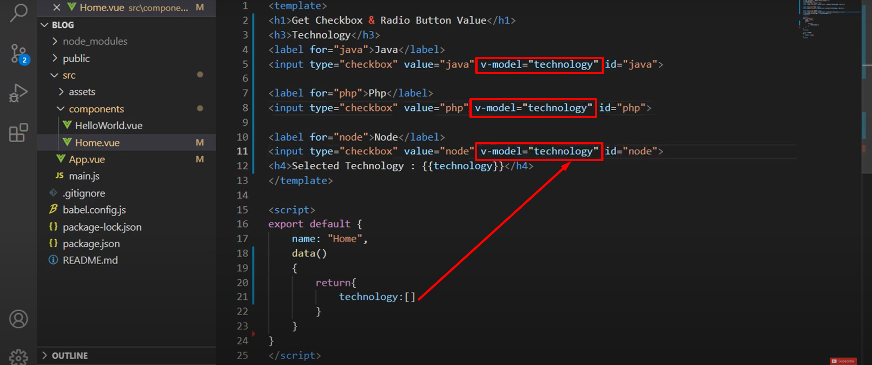
3. 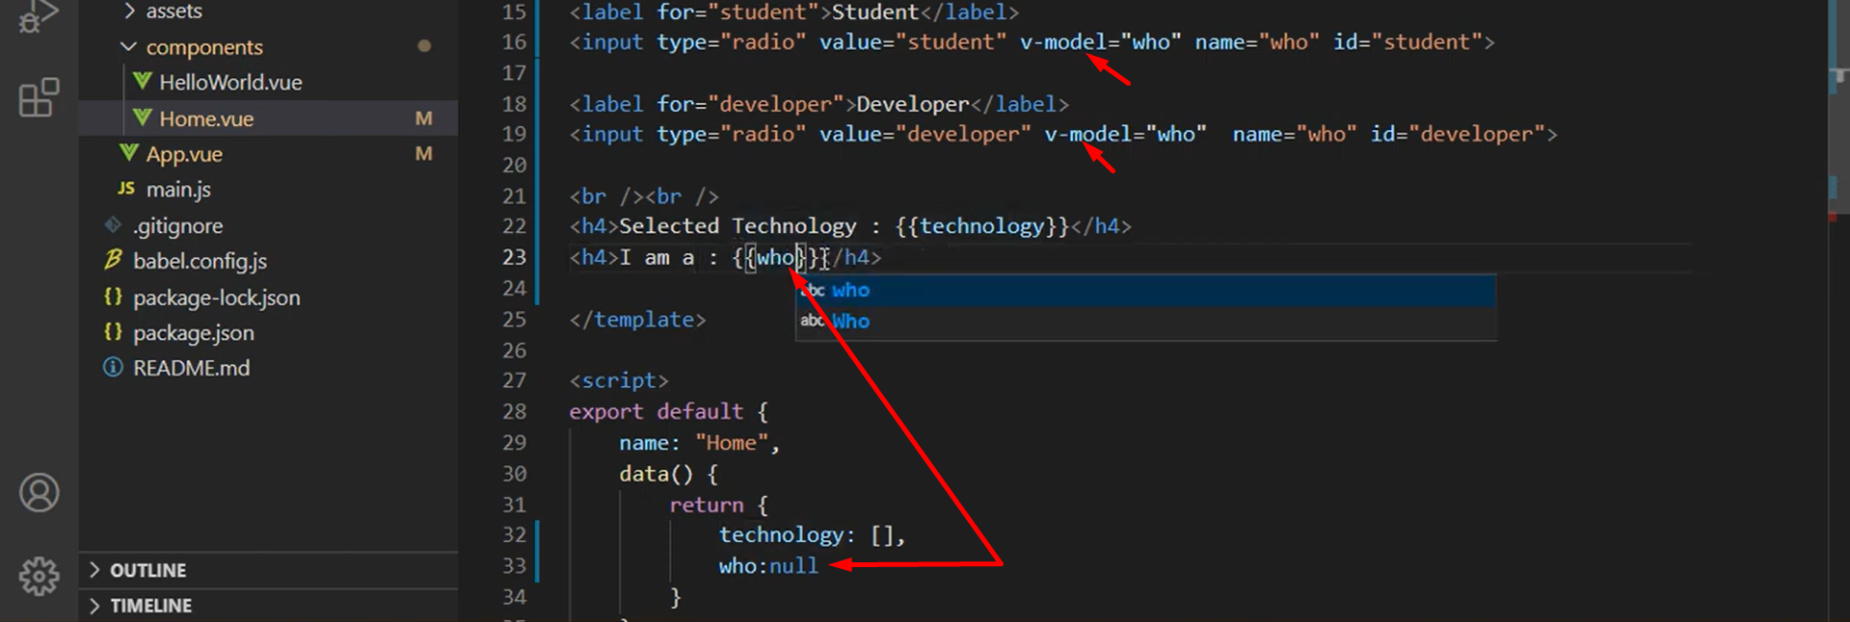

# Vue JS 3 tutorial in Hindi #13 if else conditions | conditional rendering

1. 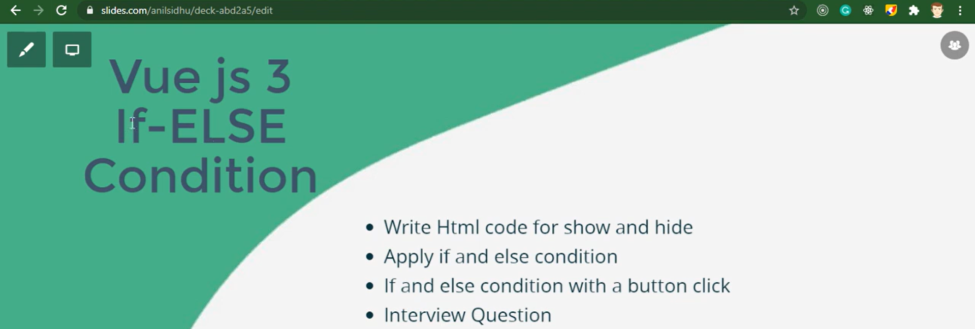
2. 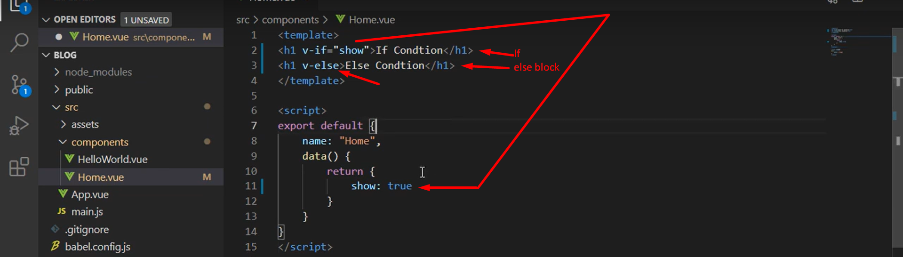
3. 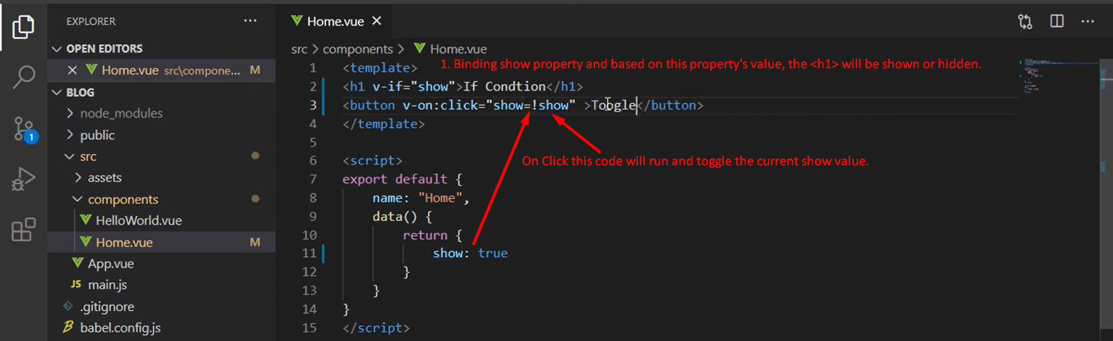
4. 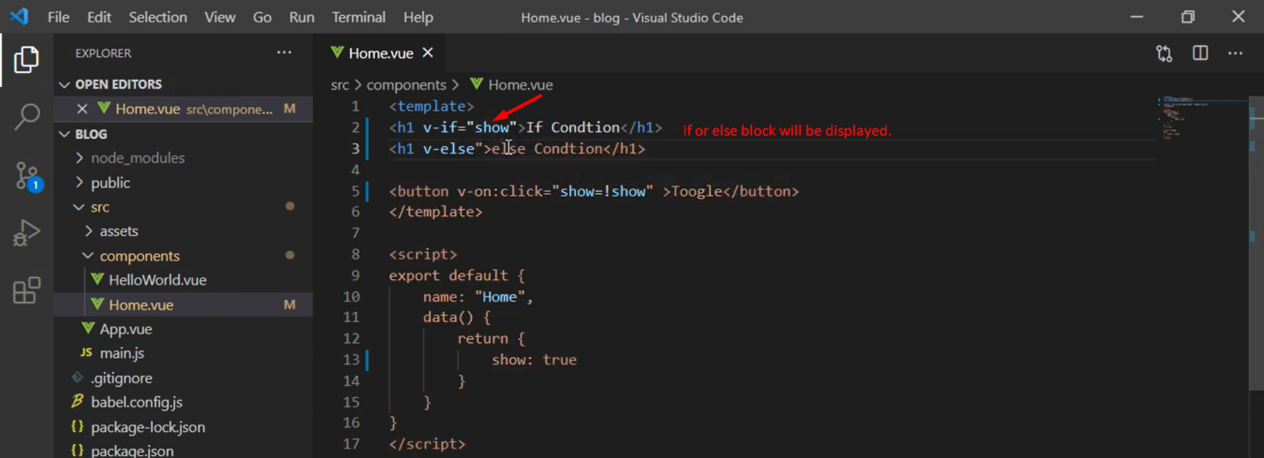

# Vue JS 3 tutorial in Hindi #14 For Loop and List

1. 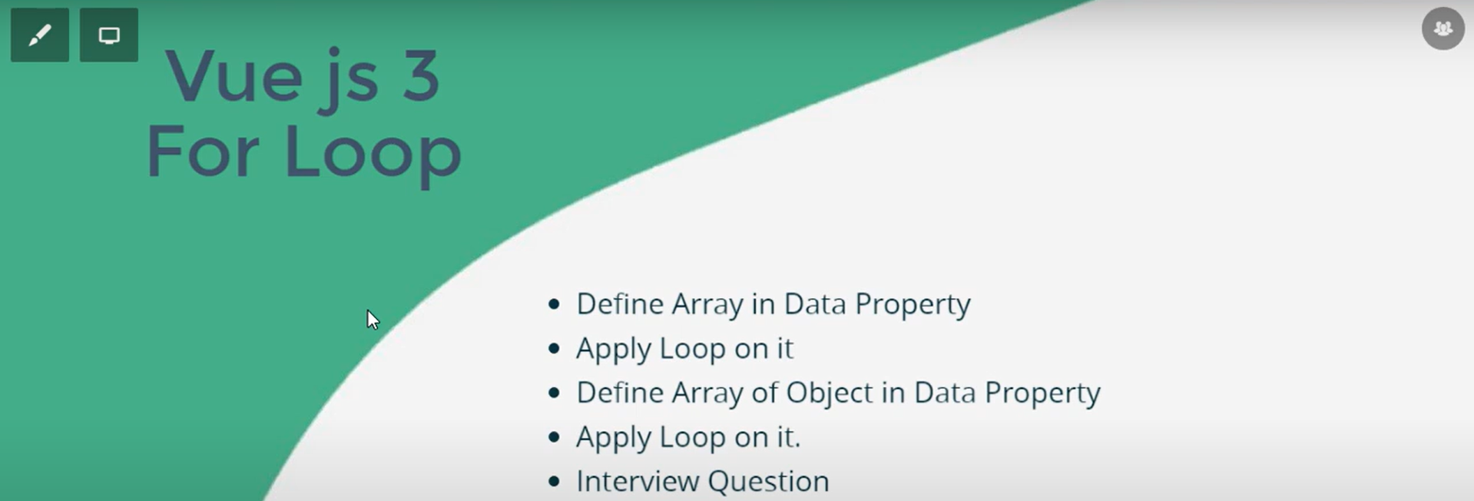
2. 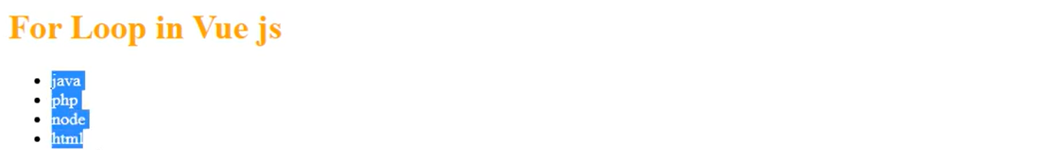
3. 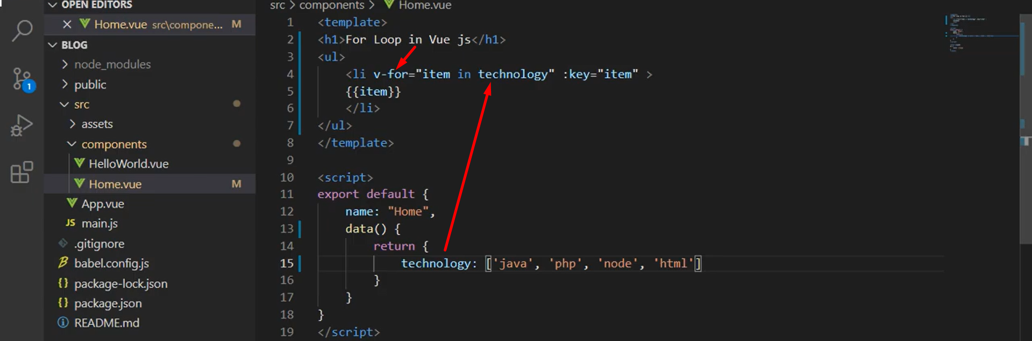
4. 

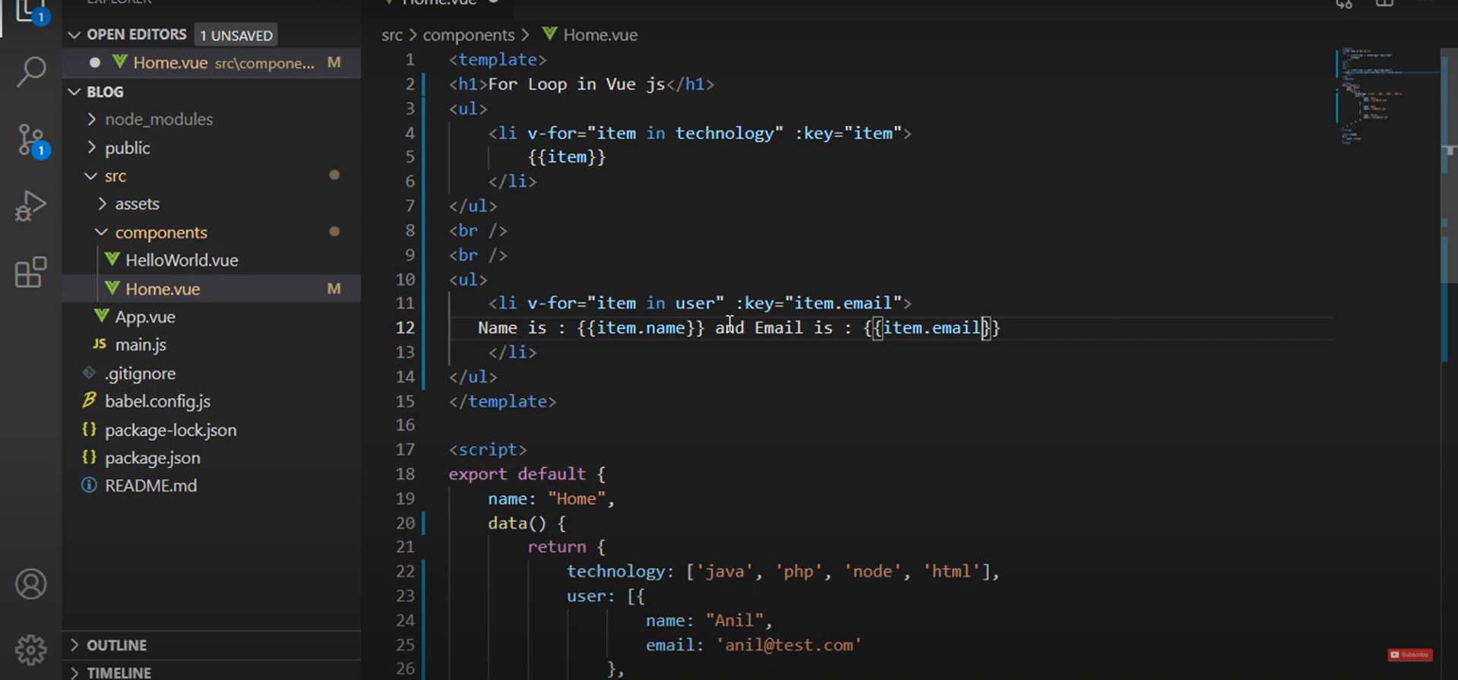

# Vue JS 3 tutorial in Hindi #15 Pass Data Parent to Child Component

1. 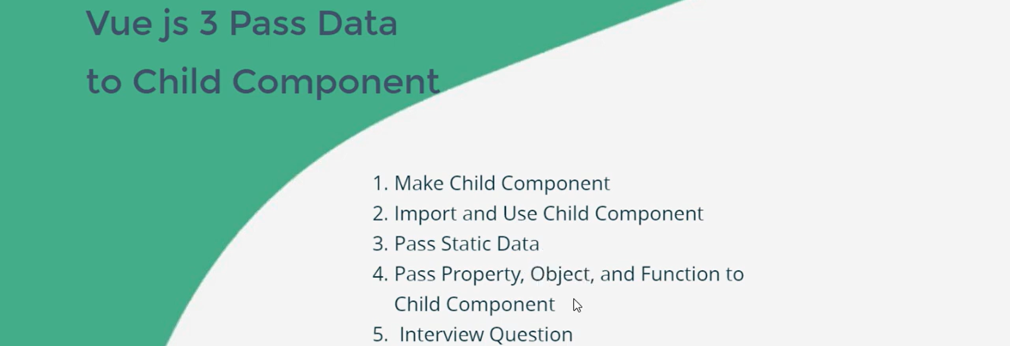
2. 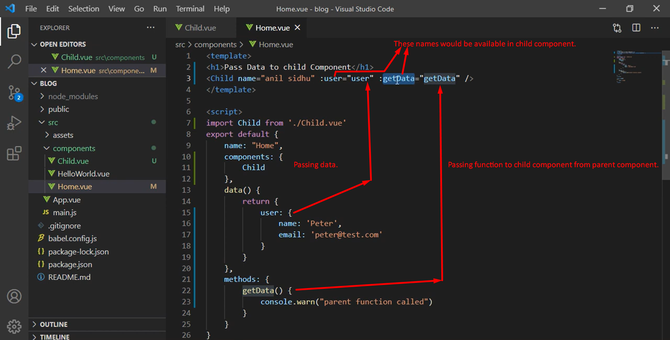
3. 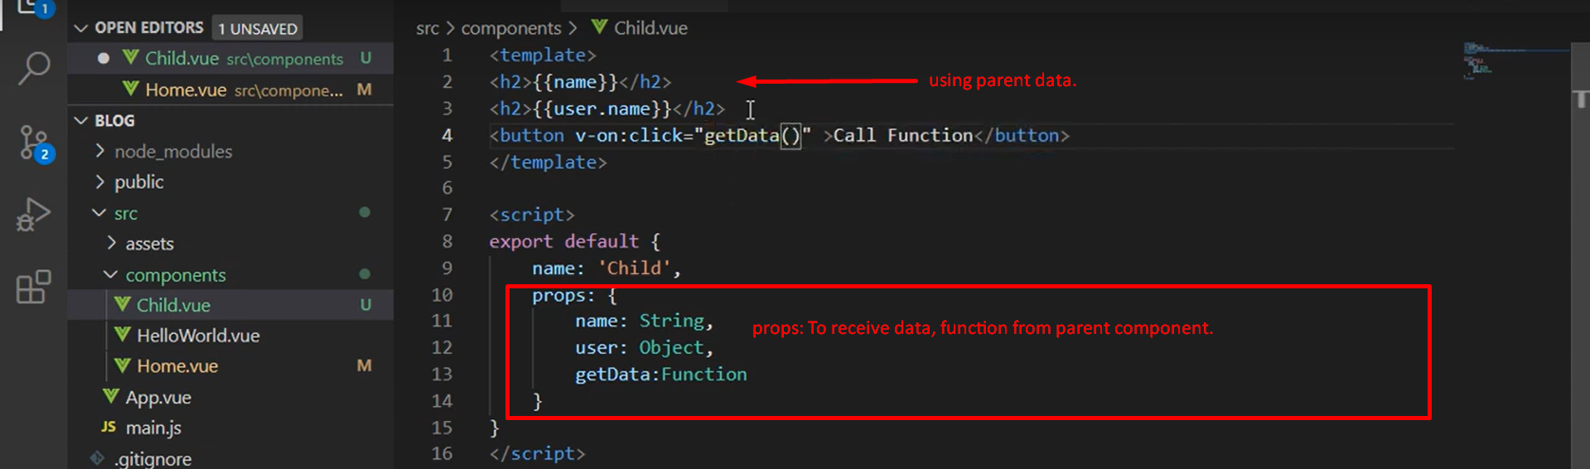
4. 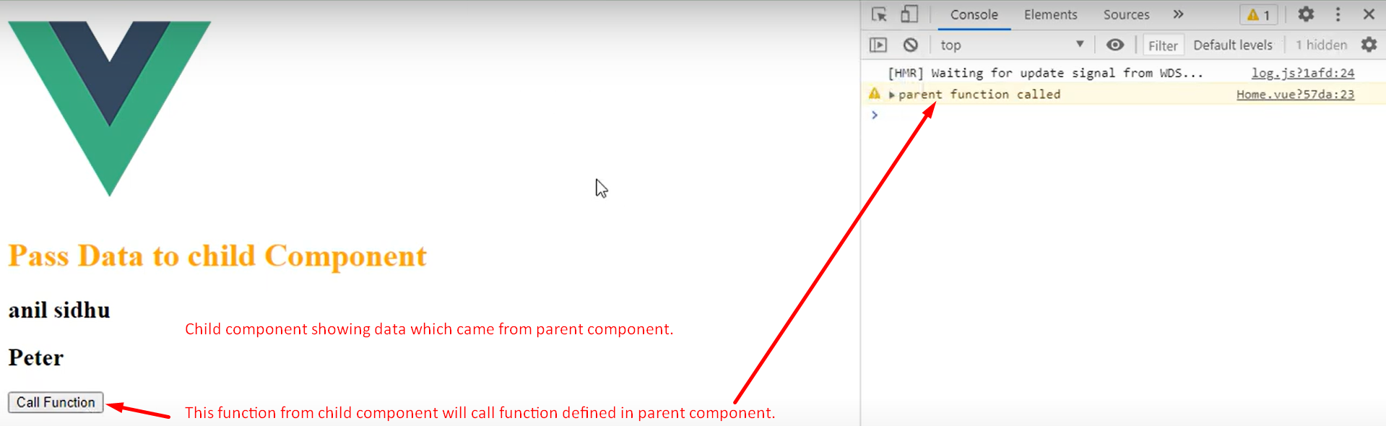

# Vue JS 3 tutorial in Hindi #16 Reuse Component

1. 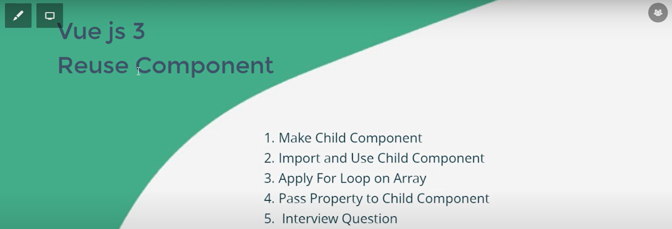
2. 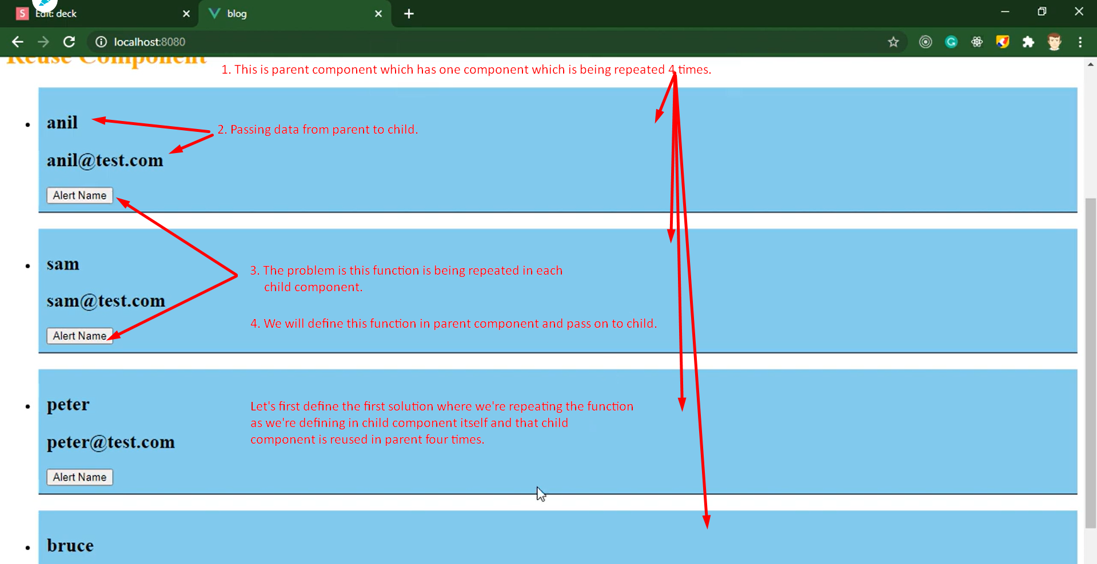
3. 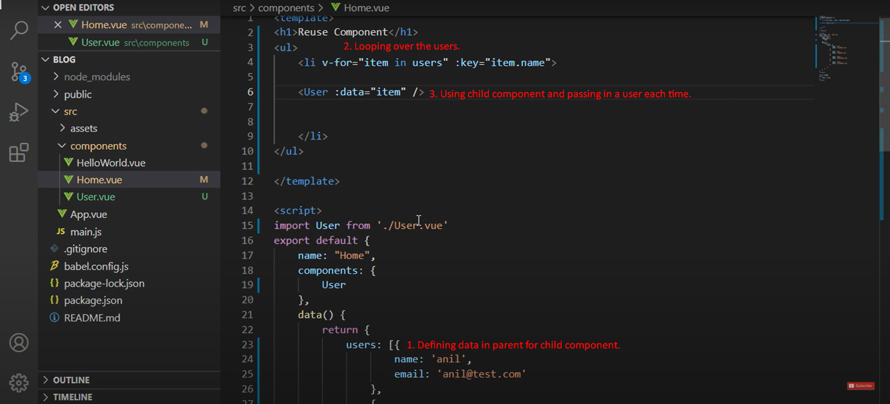
4. 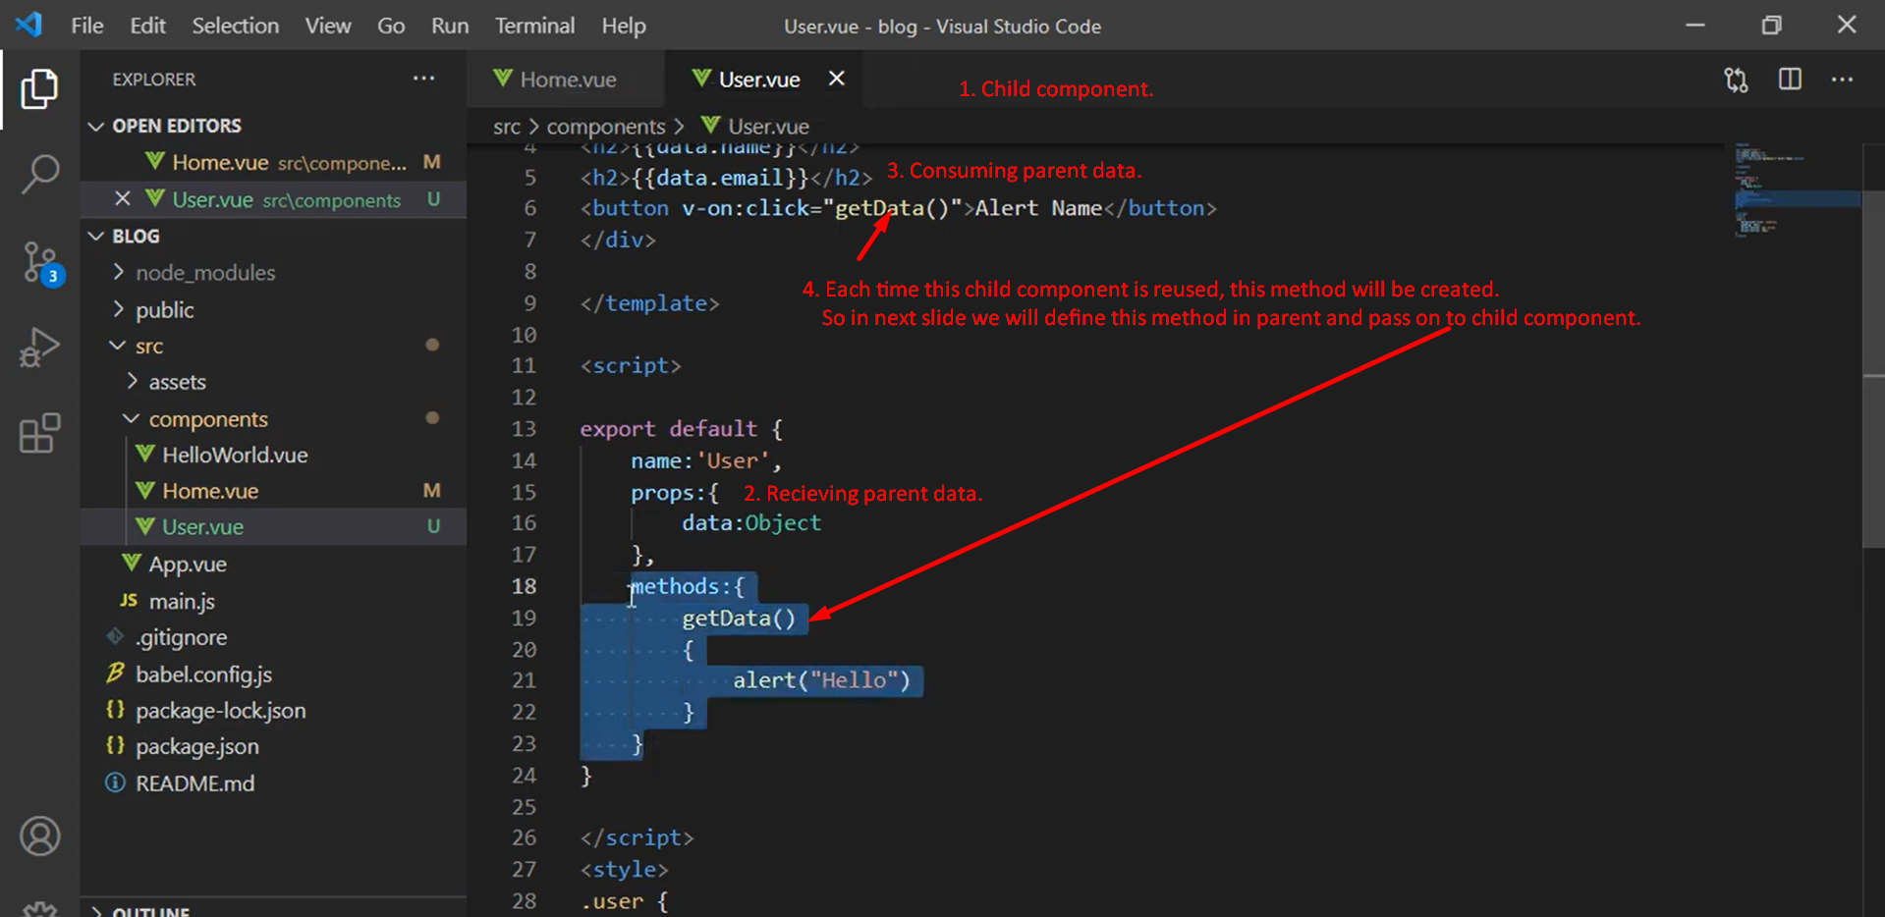
5. Let’s define the child method in parent.  
   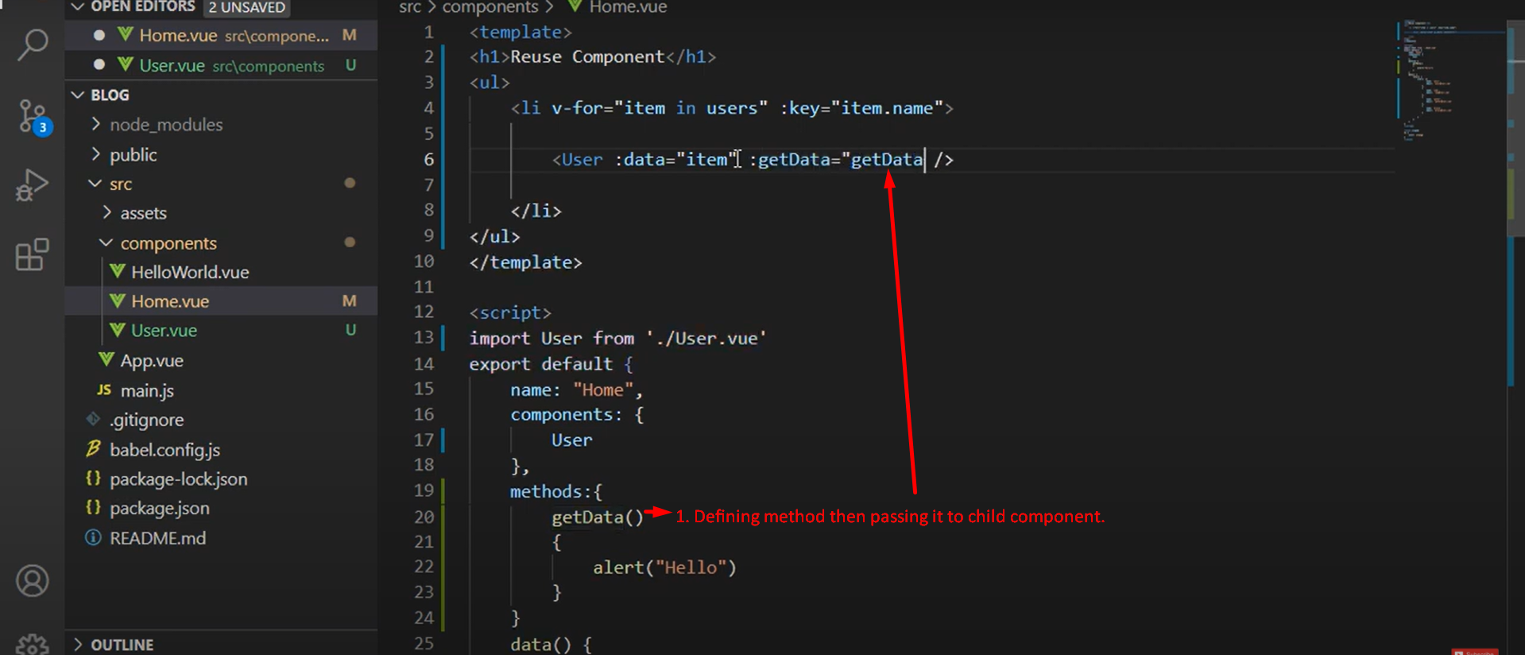  
   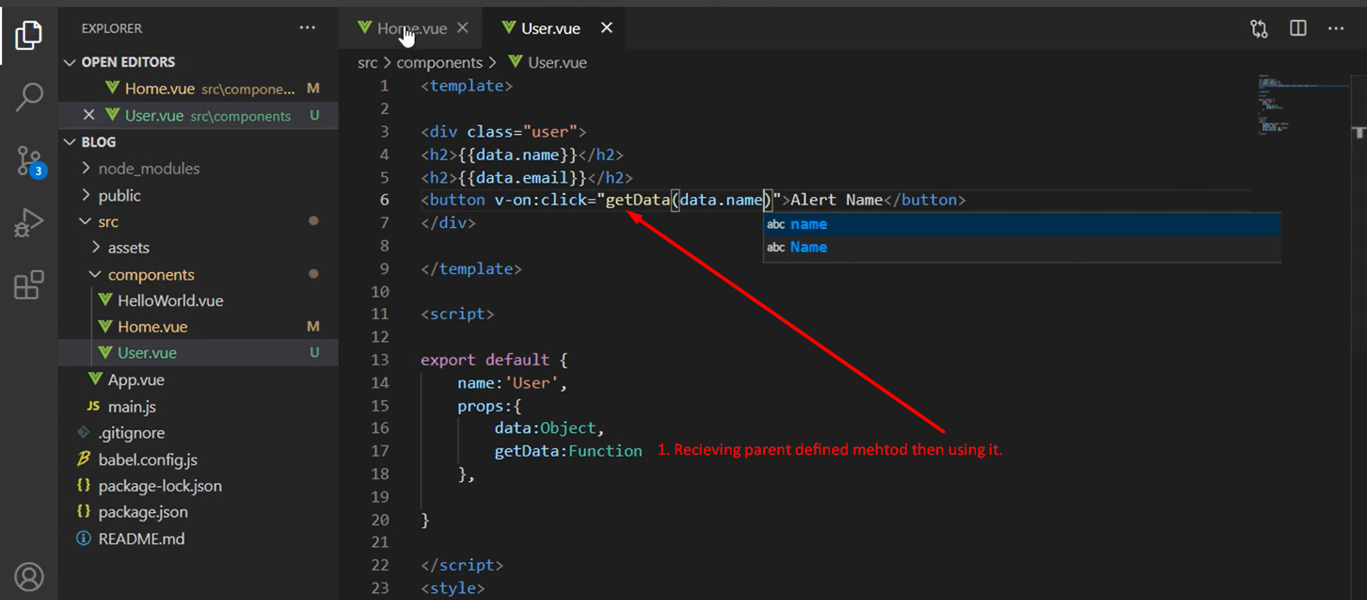  
   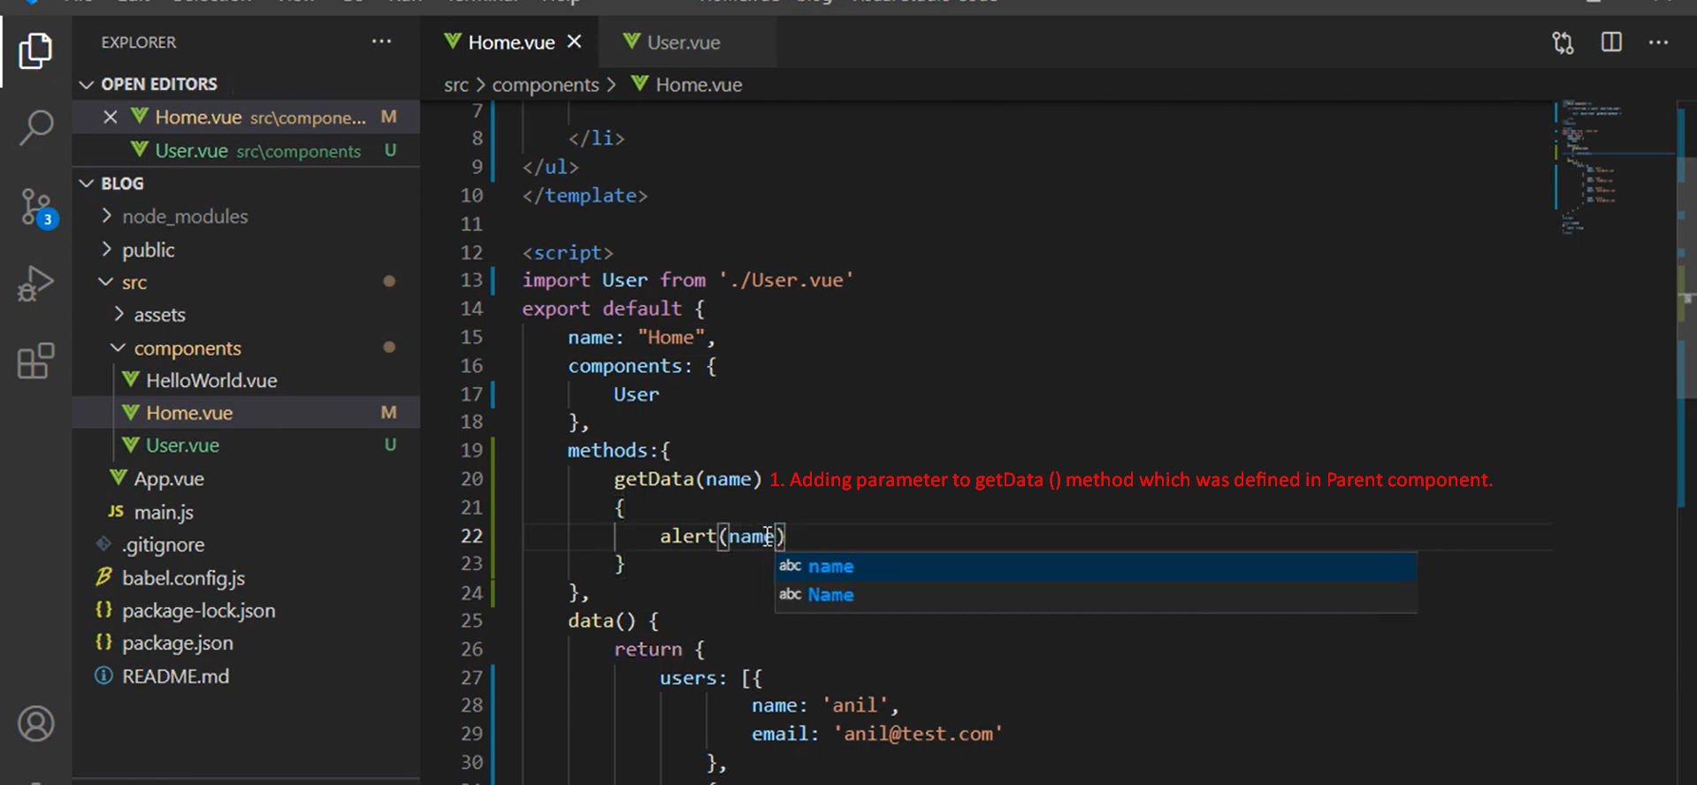

# Vue JS 3 tutorial in Hindi #17 HTML binding

1. 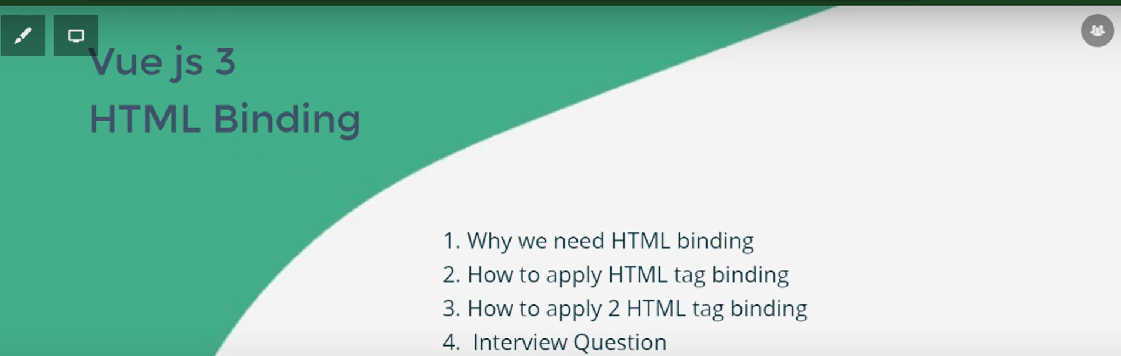
2. 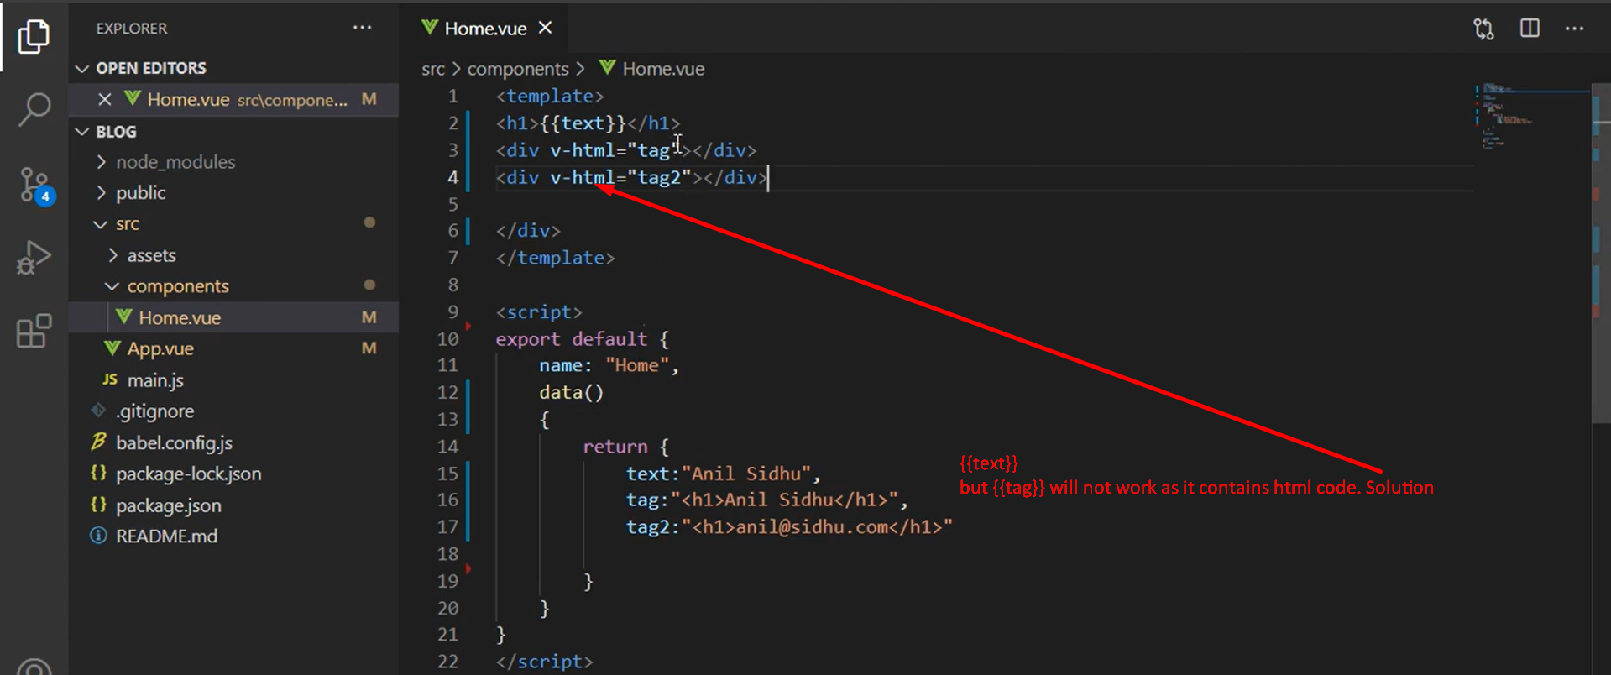

# Vue JS 3 tutorial in Hindi #18 Class Binding | Dynamic Style

1. 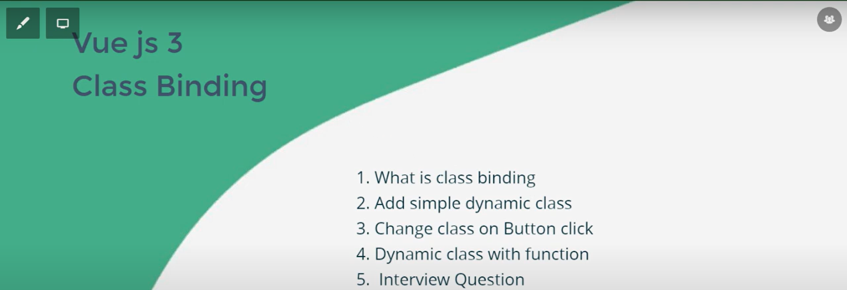
2. To add style dynamically.
3. 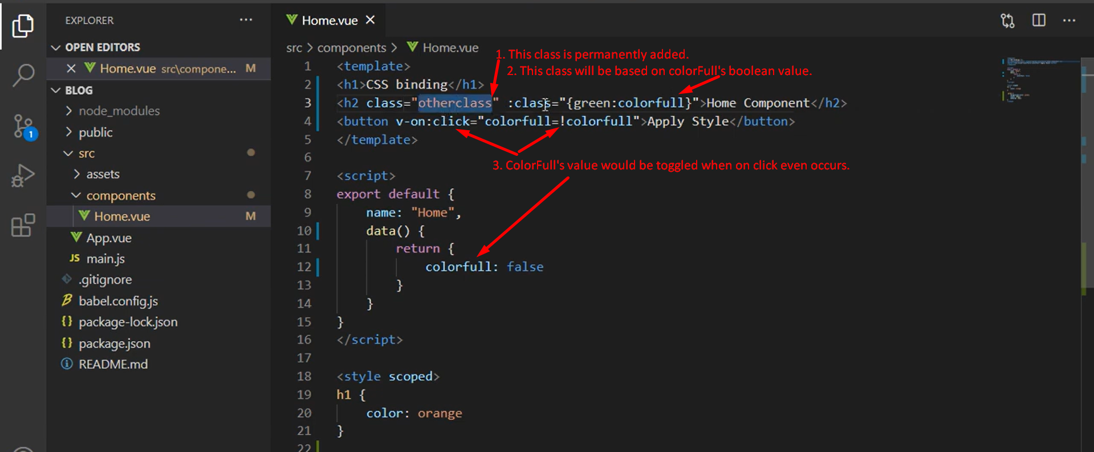
4. 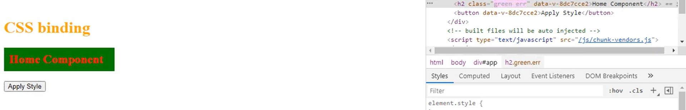
5. 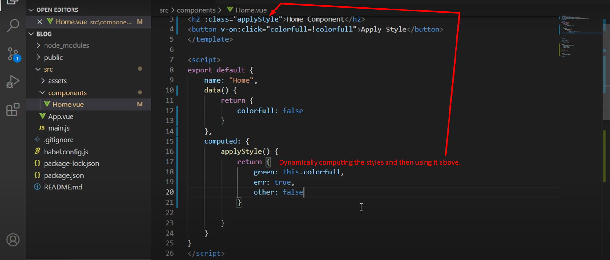

# Vue JS 3 tutorial in Hindi #19 Props with example

1. 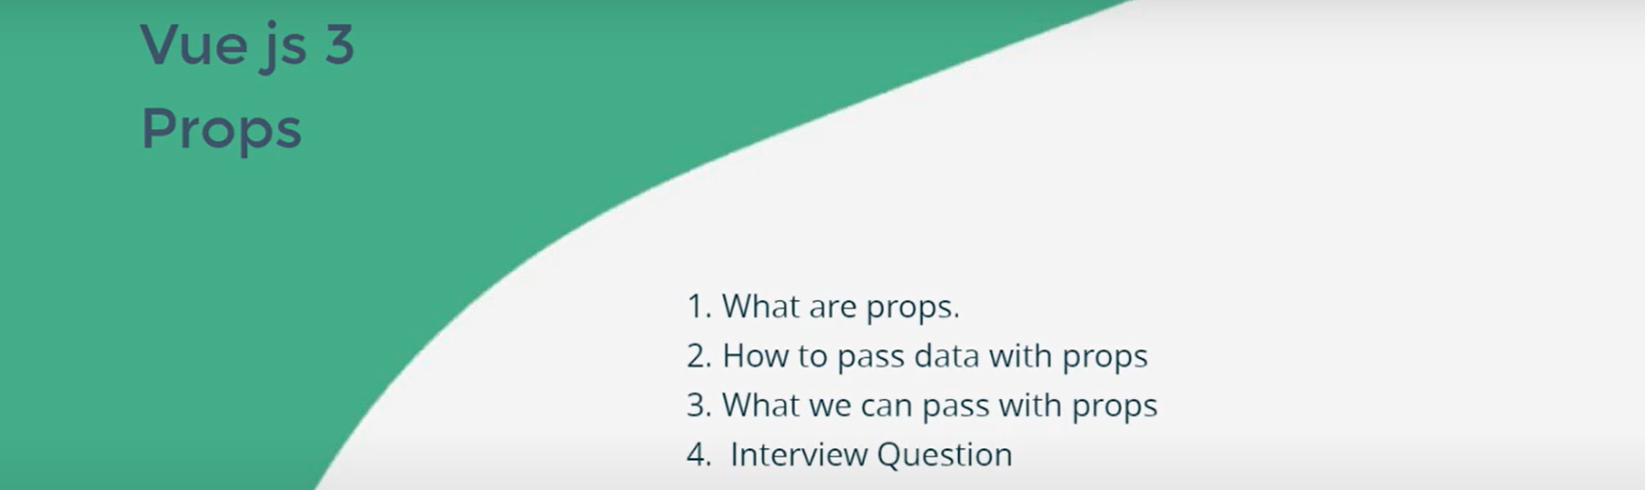
2. NOTE: Can be transferred from
   1. parent to child
   2. parent to sibling.
   3. child to parent.  
      **NOTE**: To transfer data/function, props are used.
3. Nothing special.

# Vue JS 3 tutorial in Hindi #20 send child to parent data component

1. 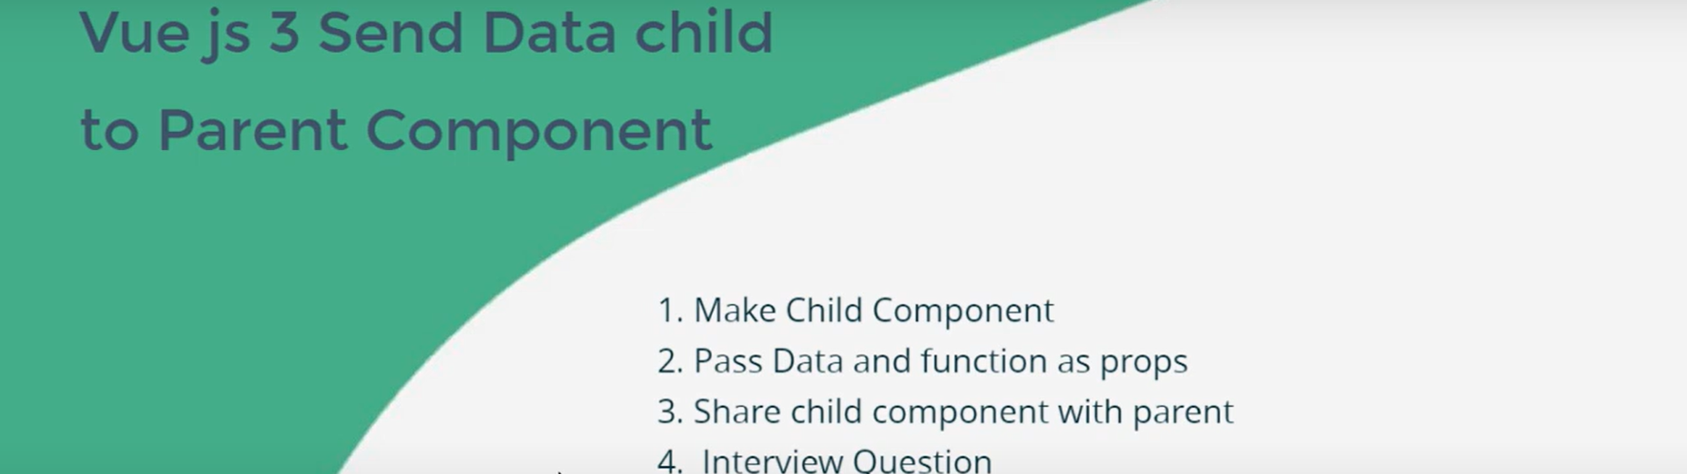
2. 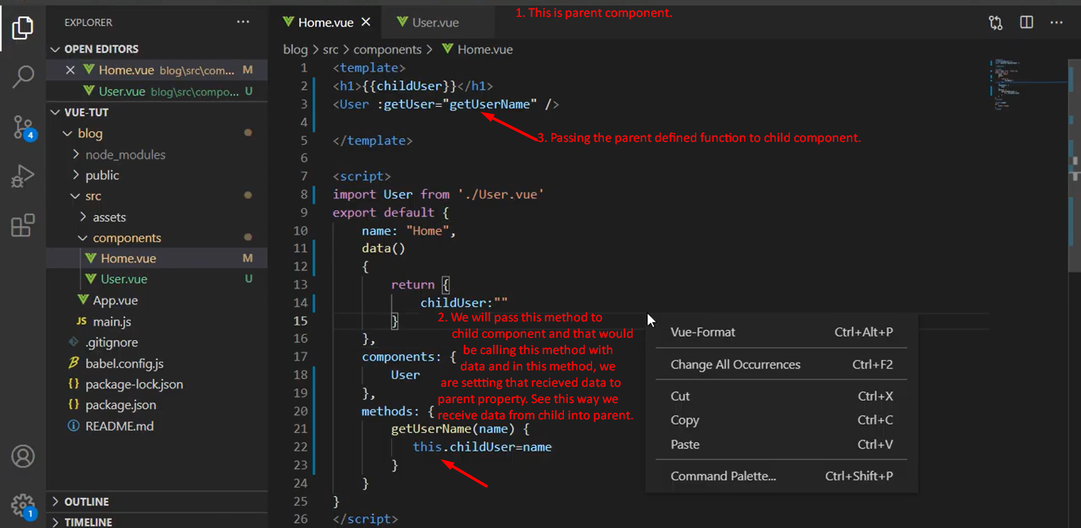  
   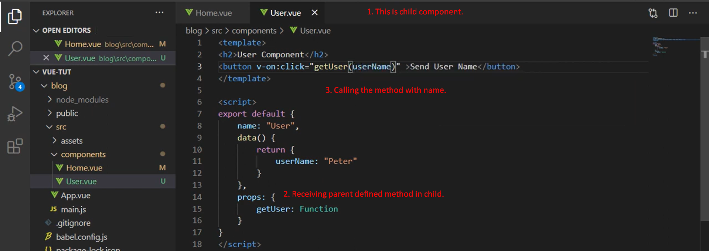

# Vue JS 3 tutorial in Hindi #21 Ref with Interview question

1. 
2. To manipulate DOM.
3. **Application**:
   1. When submitting form, some error and you want to focus those error fields.
   2. To get/set form value.
   3. To set styles of a form.
4. 
5. 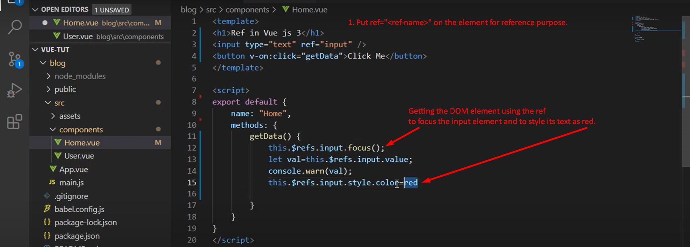

# Vue JS 3 tutorial in Hindi #22 Simple Form

1. 